Dunshaughlin Nursery Programme 2021

Session Plan Date: 27/8/2021

WARM UP- All Stations
*Introduce yourselves to group*

- Warm Up – Circle Time

ACTIVITY PLANNER

COORDINATION - CIRCLE TIME
HURLING / FOOTBALL — FITNESS EXERCISE
These are warm-up exercises that may be used before any other ABC or Have-a-Ball exercise
Organisation
- Sit the players in a circle
- The coach guides them through a series of exercises using the hands and feet
- Include raising the feet off the ground and tapping the hands and feet off the ground
Key Points
- Gradually increase the intensity of the activity – stretching, reaching out/up/down/behind, rolling forward/backward/sideways, bending, jumping, cartwheel or whatever gets them moving around
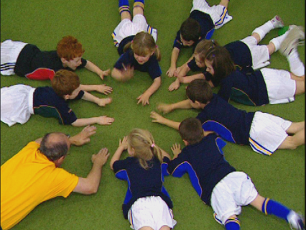

Station 1 Astro
Station Skill: AGILITY & COORDINATION
Activity 1: MUSICAL CHAIRS

ACTIVITY PLANNER

AGILITY - MUSICAL CHAIRS
HURLING / FOOTBALL — FITNESS EXERCISE
This exercise to develop agility skills is generally suitable for players of 4-6 years
Organisation
- The players run around the playing area randomly
- On a signal from the coach each player must find a marker in order to remain in the game
- One marker is removed before each round until only one player remains
Key Points
- No pushing or bumping
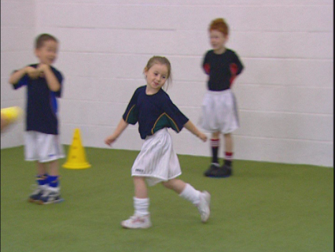

Adaptation-Make it easier: Begin with movements slow walk or slow jog
Progression-Make it harder: To make it harder- have lots of different colour cones out but the kids must just use one specific colour cones for the musical chair game.
Keep it interesting by altering the type of movement – running, crawling, hopping, crawling, backwards, sideways etc
Don’t let the kids just hover near a cone- they must move around
Have a child help as instructor and think of action etc

Station 2 Astro
Station Skill: KICKING & BALL SENSE
Activity 1:

ACTIVITY PLANNER

KICKING- DRIBBLE THROUGH MINEFIELD
FOOTBALL — BALL SENSE
These exercises challenge the players to dribble a ball around the playing area using the feet
Organisation
- Each player has a ball
- Dribble the ball through the playing area avoiding the caps or domes
- To vary, the players may be divided into groups; one or more groups navigate the minefield on a signal from the coach
Key Points
- Look up frequently to track the paths of other players
- Using both feet, use the front, the inside and the outside of the foot to control the ball
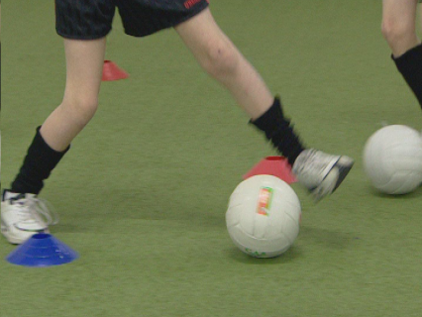

Adaptation-Make it easier: Begin with movements slow walk or slow jog around the playing area
Progression-Make it harder & a game
Divide into 2 teams. Start them on either side of a large playing area. Have 2 teams cross the playing area at the same time (going in opposite directions) and see which team gets all their players to the other side first. They need to look up, keep control of ball etc so encourage accuracy and control over speeding across. Set out the finish line on either side with a line of cones.
Get some kids to use just weaker foot if its too easy.

Station 3 Astro
Station Skill: BALL SENSE
- Activity 1: Toss & Clap Relay

ACTIVITY PLANNER

CATCHING & PASSING - TOSS & CLAP RELAY
HURLING / FOOTBALL — BALL SENSE
This exercise to develop catching & passing skills is generally suitable for players of 4-6 years
Organisation
- Set up 2 identical relay courses using a variety of equipment
- Challenge the players to navigate the course carrying a ball, tossing it into the air and clapping before catching it again and returning to the end of the line
Key Points
- Ensure the players have enough room to perform the exercise safely
- Catch the ball with two hands at first before progressing to one hand

Adaptation-Make it easier: Walk the course
Progression-Make it harder: Perform while jogging. Add in extra skills like a circuit with the bounce, circuit with thigh solo and then full solo for those who can manage it.

Station 4 Astro
Station Skill: CATCHING & PASSING
Activity 1:

ACTIVITY PLANNER

CATCHING & PASSING - PASS IN A LADDER
HURLING / FOOTBALL — BALL SENSE
This is an exercise to develop coordination, catching & passing skills which uses training ladders
Organisation
- The players work in pairs; each player in a ladder
- Shuffle through the ladder sideways facing the other player
- Throw the ball to one another as you move along
Key Points
- Ensure the ladder is properly laid out; reset it if necessary before each ‘go’
- Move at a controlled pace
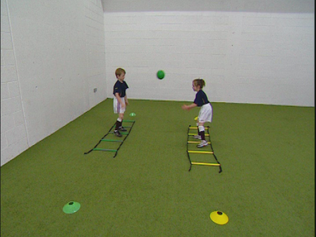

Adaptation-Start with ladders close together
Progression-Move ladders further apart. Add in more skills in sequence – pass/catch, bounce pass, hand pass, ground foot pass

Station 5 Astro & Grass Pitch
Station Skill: INTRODUCTION TO MATCHES , MOVEMENT OF PLAY ETC

Astro:
  - Possession Game without goal – split into 2 teams. Each team must pass to each other while the other team try to get ball off them. See how many passes they can manage. Try it as a piggy in the middle game to keep attacking team in a certain area and playing team have a chance to pass. Use cones to mark area and adapt it as you need to for weak passing players etc (let them move either side of their spot)
  - Possession Game with Goal – split into two teams in a large playing area. Mark 2 square goal areas with cones on either side of the area. Teams must work together to pass the ball, and work it into the goal area for 1 point.
Focus on kids learning direction of the play (where is their goal). Kids looking to pass the ball and then moving after the pass. See how many passes the team can get before being dispossessed. Try to freeze play if someone takes off running down the pitch- they must pass to earn points for their team.

