Dunshaughlin Nursery Programme 2021

Session Plan Week 11 Date: 13/08/2021

WARM UP- All Stations
*Introduce yourselves to group*

- Warm up

The Atom Game
• Players run around a fixed area in all sorts of directions.
• The coach calls out "Atom___" and a number. Which ever number is called, the children have to get into groups of that number.
For example, the teacher calls "Atom 6!" and children get into groups of 6.
Shapes

Repeat above but call out shape to be formed by players e.g. Triangle –
Get into groups of 3

Category game
• Select category for calling out to the pupils.
• Examples of categories – those who are boys, those who are 9/10/11 years old, those who are wearing watches.
• Those pupils who belong to the category will walk/jog/hop/run to a specified target and come back quickly.

Station 1 Astro & Grass Pitch
Station Skill: Skills Obstacle Course
Set up an obstacle course with ladders, hoops, poles/cones, hurdles etc.

Set kids in pairs and run them through the course together.

Have areas for handpass, kick pass, ground pass, throw, catch -chest catch, overhead catch etc.

Focus on kids moving and working together, focus on skill technique also.

On grass pitch – build in area for solo also.

Station 2 Astro & Grass Pitch
Station Skill: Kicking
Activity 1: Foot Solo
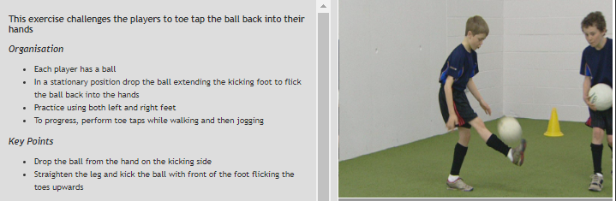
Adaptation-Make it easier: (Astro) – Start with Thigh Solo – Drop the ball from hand to tap it with thigh before catching
Progression-Make it harder: (Grass) - Perform while walking and then jogging
Loads of motivation in both groups

Station 3 Astro & Grass Pitch
Station Skill: Catching – Body catch

ACTIVITY PLANNER

BODY CATCH - OVER THE RIVER
FOOTBALL — FUN ROUTINE

This is a court game to develop the body catch technique
Organisation
- Mark out a grid or ‘court’ using cones
- Divide the players into two teams of 4
- The objective of the game is to throw the ball into the opposition team’s ‘court’ making it difficult for them to catch
- The opposition team must use the Body Catch technique
- 1 point is awarded if the opposition fail to catch the ball using the body catch, or if the ball is dropped
- Award 1 point to the opposition is if the ball is thrown outside the court
STEP Variation
Players at beginning - Reduce the number of players on each team to provide more touches on the ball
Have players kick the ball and make it more challenging for other team to catch.

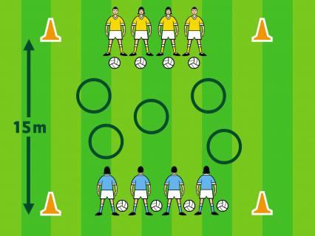

Station 4 Astro & Grass Pitch
Station Skill: Fun / Agility
Stuck in the Mud

• One player ‘on’ for every 7 in the group. They have to chase and tag the players not 'on'.
• When players are tagged they is 'stuck in the mud'. They stand with legs and arms out and they cannot move.
• They are released when a player who is not stuck goes under the players legs.
• This continues until everybody is stuck. Use more catchers to increase the difficulty.

On grass pitch – add in a ball. Only those with a ball can free the others.

Station 5 Astro & Grass Pitch
Station Skill: INTRODUCTION TO MATCHES AND MATCH RULES

*Slightly different approach between Astro and the Grass Pitch*
Astro Match:
- Split group and play small sided matches: 2 V 2 or 3 v 3 at most
- Priority is time on the ball and touches of the ball for all kids
- Teach direction of the play
- Teach about team work and looking to pass to team mate
- Let them run with the ball until they get these basics
- Then progress to remind them to bounce the ball once when they run with it
- Kicking will come later if they are ready
Grass Pitch Match:
- Split the group into 2 and play small sides games: 2 V 2 or 3 V 3 at most
- Priority is time on the ball and touches of the ball for all kids
- They should know direction of play-but check
- Teach rules of the game: 4 steps, bounce, kick, handpass, score
- Team teamwork and passing to a team mate

